MediConnectLite — Phase 1 Submission

Student: Jaskaran Singh Course: Android Development

Overview
I created a native Android app concept called MediConnectLite. The goal is to help users discover doctors by category, book appointments, see upcoming and past bookings, and manage profile details. For Phase 1 I planned the database and built an application shell that follows Material Design.

App Shell — Emulator Screenshots
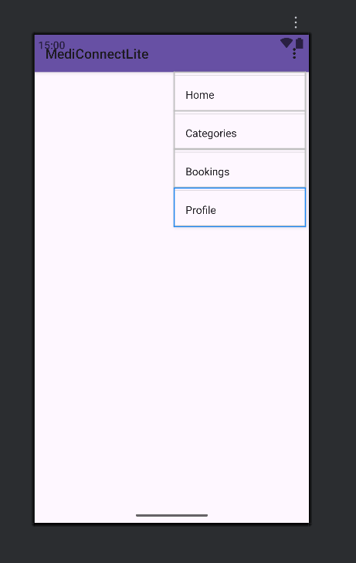
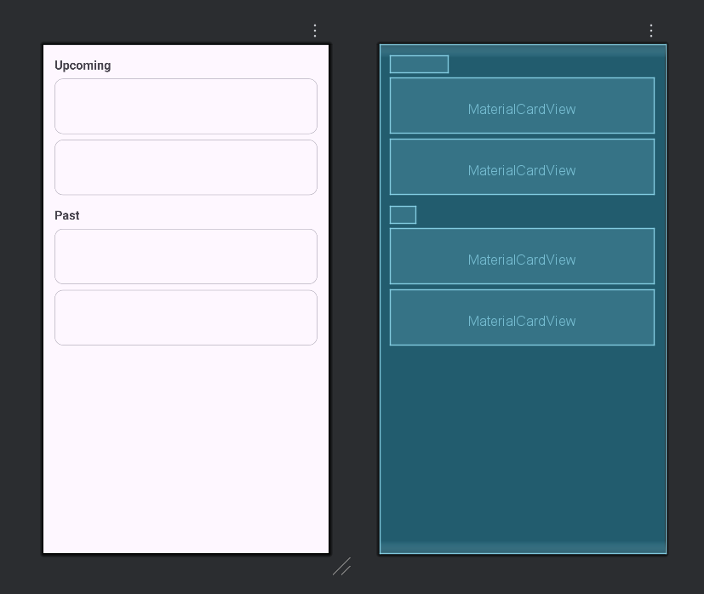

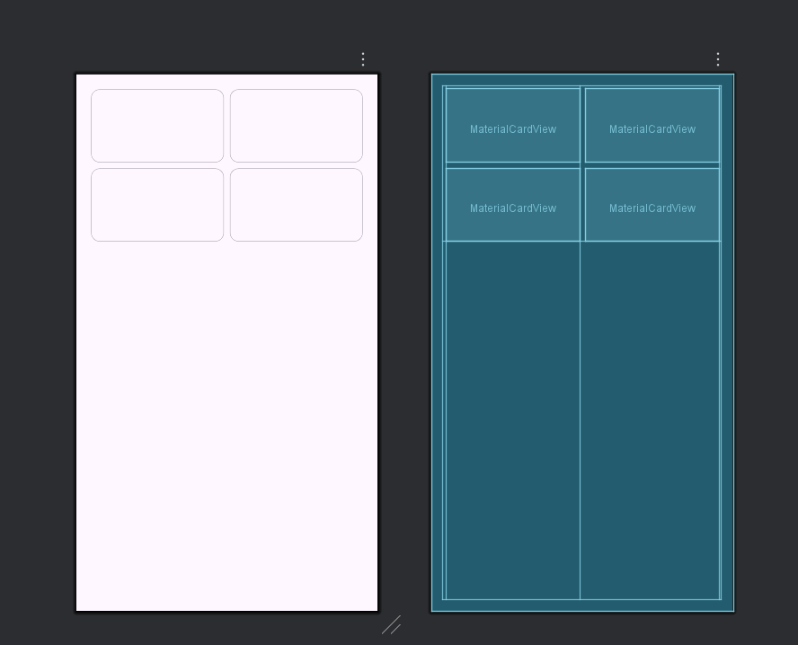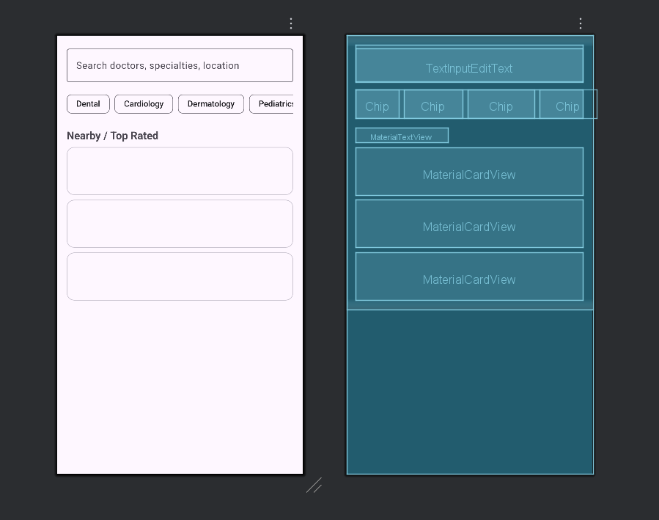

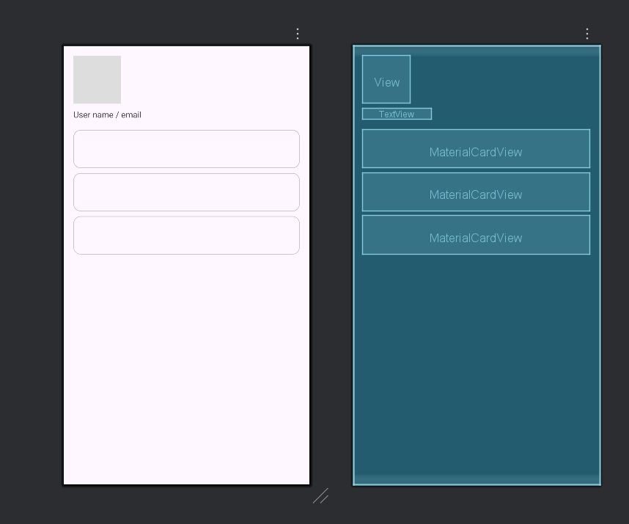

Non Relational Database — Initial Collections
Collection | Example fields
users | uid, name, email, phone, role (patient or doctor), avatarUrl, createdAt
doctors | doctorId, name, specialtyIds[], clinicId, rating, yearsExperience, bio, photoUr
clinics | clinicId, name, address, city, geo, phone, hours
appointments | apptId, patientUid, doctorId, clinicId, dateTime, status, reason, notes
specialties | specialtyId, name, icon
availability_slots | slotId, doctorId, date, startTime, endTime, isBooked
reviews | reviewId, doctorId, patientUid, rating, comment, createdAt
notifications | notifId, userUid, type, payload, isRead, createdAt

l

Android Studio App Shell — What I built
MainActivity hosts a Material toolbar at the top, a NavHostFragment in the middle, and a BottomNavigationView. Fragments created: Home, Categories, Bookings, Profile. Each fragment contains a simple Material layout so I can iterate later. Navigation Component is wired with a navigation graph.

Framework of MediConnectLite
App name MediConnectLite. Language Kotlin. The app uses fragments with a bottom navigation bar. Home shows search and quick categories. Categories shows a grid of specialties. Bookings separates upcoming and past. Profile shows user info and actions. This framework prepares the app for authentication and real data in Phase 2.

Reflection and Next Steps
Phase 1 demonstrates a working shell that compiles and runs with navigation and Material layouts. Next I will add Firebase authentication, store user and doctor data, implement appointment creation and list, and refine the theme and icons to match the wireframe.

Wireframe
Splash / Onboarding

App Bar
Logo: MediConnect Lite
Find doctors. Book fast.

Get Started

Sign In

Wireframe Authentication
Create account
Forgot Password?

Sign In (Button)

Password (TextField)

Email (TextField)
App Bar: Sign In

Wireframe
Home
B
App Bar: MediConnect Lite

Search doctors, specialties, location
Quick Categories (chips/icons)
Nearby / Top Rated Doctors (cards)

Recent Bookings / Tips

ottom Nav (Home Categories Bookings Profile)

Wireframe
Categories
Doctors

App Bar: Categories
Specialties Grid (Cardiology, Dental...)
Filter: Location Rating

Doctor list (by selected specialty)

Bottom Nav

Wireframe Doctor Details & Availability
App Bar: Dr. Name

Photo Specialty Location Rating
Clinic description / Bio
Availability Slots (grid)

Book Appointment (button)

Bottom Nav

Wireframe
Booking
Select Date
Bottom Nav

Confirm Booking

Reason / Notes
Select Time Slot
App Bar: Booking

Wireframe Bookings Upcoming & Past
App Bar: My Bookings

Upcoming (cards)

Past (cards)

Cancel / Reschedule

Bottom Nav

Wireframe
Profile

App Bar: Profile
User info (name, email, phone)
Manage Addresses

Notification preferences

Sign out

Bottom Nav

